University of Québec in Rimouski
Management science Department

Course: Business English
Number: ANG-100-10
Semester: Winter 2018

Project of Team’s paperwork
Cunard: A mythical Company

Presented to
Mister François Émond

By
Mrs. Hélène Montreuil
Matriculated: MONH07565205

Québec, April 18th 2018

Mister Professor,

I would like to present a paperwork about a mythical company, The Cunard Cruise Line.

I have chosen this company for two main reasons. First one, I enjoy a cruise on a Cunard ship because I like the British perfume of the twenties that you can feel when you are on board. Secondly, a Canadian, Samuel Cunard, established this company in 1838. Mister Cunard is born in Halifax in 1787, but he also lived in Prince Edward Island.

Through more than 175 years this company has crossed all the oceans of the World to establish a tradition of the way of living in Britain. So, there is Cunard Cruise Line and there are the other cruise line companies.

However, I must warn you; Cunard is only a subsidiary of Carnival Corporation, the world's largest travel leisure company, with a combined fleet of over 100 vessels across 10 different cruise line brands. Those brands are:

- AIDA Cruises, in Rostock, Germany
- Carnival Cruise Line, in Miami, Florida
- Costa Cruises, in Genoa, Italy
- Cunard Line, in Southampton, United Kingdom
- Fathom, in Miami, Florida
- Holland America Line, in Seattle, Washington
- P&O Cruises, in Southampton, United Kingdom
- P&O Cruises Australia, in North Sidney, Australia
- Princess Cruises, in Santa Clara, California
- Seabourn Cruise Line, in Seattle, Washington

The biggest ones are Carnival Cruise Line with 26 ships, Costa with 15 ships, Holland America with 15 ships and Princess with 17 ships. So, with only 3 ships, Cunard looks very small. However Cunard has been one of Carnival's most high-profile brands.

With the legendary popularity of the famous Queen Elizabeth 2 and the development of the world's largest trans-Atlantic Ocean liner, the Queen Mary 2, which continues to be the flagship of the fleet, Cunard has established a new standard, the British One. You must know that Cunard is the only company in the world that regularly crosses the Atlantic Ocean from Southampton to New York and vice-versa with the Queen Mary 2. This ship has been built to cross the ocean.

The other cruise line brands have different targets about young people like Carnival, European and Italian people with multiple language skills like Costa, classic style with smaller ships like Holland America, senior citizens like Princess, and so on, but there is just one Cunard for people who love the British style of the twenties.

Now about the history of Cunard

Cunard was established in 1838 by a Canadian, Samuel Cunard, who obtained the first trans-Atlantic mail contract in 1837 and established the British and North American Royal Mail Steam-Packet Company in 1840. It is the beginning of Cunard as a mailman. The letters R.M.S. always preceded the names of its ships, which means Royal Mail Ship.

However, other companies, mainly British and German decided to build bigger and faster ships. Between 1897 and 1904, the Germans will build the Kaiser Wilhelm der Grosse, the Deutschland, the Kronprinz Wilhem and the Kaiser Whilhem II. In answer to that, Cunard will build the Lusitania and the Mauritania in 1906. The British company, the White Star, will build the Olympic in 1911, the Titanic in 1912 and the Britannic in 1914. After the First World War, France will build the Normandie while Cunard will build the Queen Mary. All these ships were racing for the Blue Riband, a kind of trophy given to the fastest ship to cross the Atlantic Ocean. These four ships, the Lusitania, the Mauritania, the Normandie and the Queen Mary have won the Blue Riband. In 1934, Cunard purchases half of the shares of the White Star and in 1947, Cunard purchases the remaining of the shares. Finally, in 1998, Carnival purchases the shares of Cunard.

A new ship is to join Queen Mary 2, Queen Victoria and Queen Elizabeth as the fourth member of the fleet. She will be the first new Cunard ship in 12 years, making it the first time since 1998 that Cunard will have four ships in simultaneous service. This new ship will have a capacity of 3 000 passengers. This new ship which, for now, still does not have an official name should be ready to sail by 2022.

Cunard relaunched the QM2 in Summer 2016 following a bow-to-stern refit, while the Queen Victoria re-emerged from dry dock in June 2017 following a significant facelift. New and refreshed cabins furnished in smart purple, navy and gold offer more accommodation for solo travellers and include a significant number of suite categories. As a solo traveller, I like it because even if there were cabins for solo travelers on the Queen Victoria, there was none on the Queen Mary 2.

The price of a cabin is calculated in thinking that there will be two people in this cabin. So, if you travel alone, you are generally obliged to pay double price. On the new ships, there are smaller cabins for the solo travelers. They have learned that many people travel alone and if you wish to attract them, you must offer cabin for solo travelers at an affordable price, with no surcharge or, sometimes, with a surcharge of 10, 25 or 50 %.

When I have traveled alone on the Queen Victoria of Cunard, the Serenades of the Seas of Royal Caribbean, the Norwegian Epic of Norwegian Cruise line, the Horizon and the Zenith of Pullmantur and the Prinsendam of Holland America, I always had access to a special rate because these ships can accommodate solo travelers. Furthermore, they prefer to have a paying solo traveler on board than to have an empty cabin.

Each cruise line tries to sell to you an idea, a concept that will seduce you. What will please you the most? Safari in Africa or penguins and iceberg in Alaska and Iceland? Warm sand and water of the Caribbean Islands or the ruins of Pompeii and Athens? Baltic Sea with Russia and Baltic States or Chinese cities and Australian towns and deserts? The choice is wide but the decision is yours.

The Cunard's fleet will have these four ships:

Unnamed ship – Perhaps the Queen Anne
113,000 GT (Gross Tonnage)
Passenger capacity: 3,000
Launch date: 2022

Queen Elizabeth
90,901 GT
Capacity: 2,092
Launched: 2010

Queen Victoria
90,049 GT
Capacity: 2,081
Launched: 2007
Refurbished: 2017

Queen Mary 2
151,400 GT
Capacity: 2,695
Launched: 2004
Refurbished: 2016

The Queen Mary 2 is the only dedicated passenger liner in the world, purpose-built to sail across the Atlantic. The journey from Southampton to New York takes six days and each day, Captain changes the hour on board, one hour forward or backward. So, you will never notice the changing of time when sailing from Southampton to New York and back. The unnamed ship will be the 249th vessel to sail for Cunard since the company's started in 1839 and will proudly display the iconic livery and red funnels.
While today’s Cunard fleet is young, the brand certainly isn’t. So how will it attract younger generations? Cunard does not need to change a bit to attract the youngest generations because these travelers seek one-of-a-kind experiences, something that only Cunard can offer. There is some unique aspect in dressing as a 1920s flapper. At Cunard, we celebrate the purpose of the travel and the purpose of improving the life of the passengers through travel. Even the youngest travelers seek activities that are both meaningful and unique.

Furthermore, people will continue to sail for Cunard’s luxury experience, sense of grandeur, gala events, and the ability to almost “take back time”. Certainly, the transatlantic crossing is a throwback to the Golden Age of Cruising when celebrities and world leaders sailed the Atlantic in opulence. Today’s passengers “feel” part of something grand: it’s almost if, through this experience, you have the feeling to achieve something unique in your life.

On a Cunard’s ship, passengers will not find water slides or basketball courts because they are not common attractions looked by the regular passenger on that cruise line.

However, they will find:
The Canyon Ranch SpaClub
A planetarium on Queen Mary 2
A fitness center
Wi-Fi and an onboard Internet center
Masquerade Ball
Extensive library
Trendy “port tastings” in the Carinthia Lounge.
A retro-cool afternoon tea and other options, including champagne tea or “pubby” tea in the Golden Lion Pub, my favourite place

The Golden Lion Pub offers a convincingly authentic pub experience; you would be forgiven for expecting to see a green village through the pub’s windows rather than the ocean or an exotic port of call. There you will find draught ales, delicious pub food, live sports and pub games along with some more lively activities such as the always-popular pub quizzes. Trust me, you will have a lot of fun. It is my favourite place where I enjoy the pianist and the singer.

There are also one-of-a-kind events, such as Cunard’s annual transatlantic Fashion Week cruise with top designers, fashion industry luminaries and runway shows displaying the latest fashions. It is on the Queen Mary 2.

There is something very special on the Queen Mary 2; she is the only ship today in regular cruise service that has a kennel for dogs and cats. That service is offered only on the transatlantic, but it’s convenient for those who spend time between the U.S. and UK. Believe it or not, Cunard has an approved process for pet customs / health clearances in both the U.S. and UK so pets can embark and disembark with their owners. However, pets must have a reservation, proper documentation and required inoculations.

About dressing for dinner, you want or wish to dress up? Passengers are free to join the ship’s gala, the Roaring Twenties party or the Black-and-White party. Do not miss them, they are so funny. In addition, even if four of the seven nights on a typical weeklong Cunard cruise are “informal”, you must be dressed properly.

On the web site of Vacations to go, the dress code for a Cunard ship is written in these words:

Evenings will be split into 2 different dress codes. You will be notified of the evening's dress code in your Daily Programme. Formal night attire consists of an evening or cocktail dress or smart trouser suit for ladies. A tuxedo, dinner jacket or dark suit with appropriate neck wear for men or you may wear formal national dress and military uniform. Informal evenings would consist of a required jacket and optional tie for gentlemen, while ladies should wear cocktail dresses, stylish separates or equivalent. No jeans or shorts.
After 6pm, shorts and blue or worn denim (for men and women) and sandals and sleeveless tops (for men) are not considered appropriate anywhere within the ship. Guests wishing to dress more casually are welcome to dine in the Kings Court or Lido buffet and relax in the Winter Garden or Garden Lounge bar, but should not use the other areas of the ship, including the Alternative Dining Restaurants.

Carnival Corporation

Carnival Corporation is divided in two branches: Carnival U.S.A. that controls eight cruise lines and Carnival UK that controls the two other cruise lines: Cunard and P & O brands. P & O means Peninsula and Oriental Steam Navigation Company and was established in 1836. Carnival U.S.A. has his corporate and operational headquarters in Miami, Florida, while Carnival UK has his corporate and operational headquarters in Southampton, England.

Carnival Corporation employs over 120,000 people worldwide and its 10 cruise line brands attract nearly 11.5 million guests annually, which is about 50 percent of the global cruise market. Combining more than 225,000 daily cruise guests and 100,000 shipboard employees, more than 325,000 people are sailing aboard the Carnival Corporation fleet every single day, totalling about 85 million passenger cruise days a year.

Carnival Corporation’s 10 leading brands offer a wide range of vacation experiences for millions of guests with varied leisure-time preferences from multiple backgrounds, cultures and languages. The company’s broad product offerings appeal to travelers of all kinds with many preferences, and consistently provide extraordinary vacation experiences at an outstanding value, especially when compared to similar land-based vacation options.

In 2016, Carnival Corporation’s revenue totalled $16.4 billion (U.S. dollars), which puts the company in the top 200 on the Fortune 500 list. Carnival Corporation is also number 311 on the FORBES Global 2000 list of the world’s largest, most powerful companies. Carnival Corporation’s 2016 earnings were over 40 percent higher than 2015 — and that was on top of a 40 percent growth in 2014.

Headquartered in Miami, Florida, and London, England, Carnival Corporation’s stock is dually listed on both the New York Stock Exchange and London Stock Exchange under the symbol CCL, and is the only group in the world to be included in both the S&P 500 and the FTSE 100 indices. The company established its Asia headquarters in Singapore in 2013 and now operates a multitude of offices across Asia, including locations in China.

Look at this financial statement: Carnival is really big
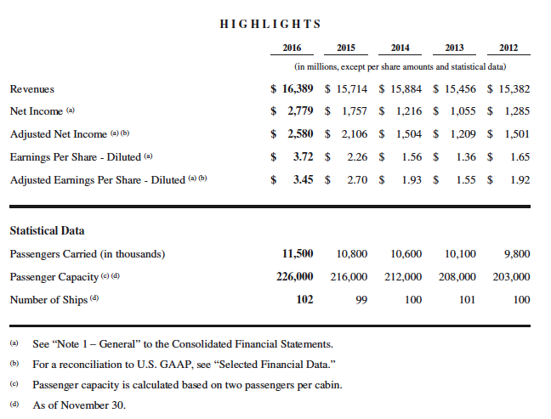

In 2010, total Carnival Corporation revenues were $14.5bn (up 7% on 2009) from the operation of 98 ships (up from 93) and two Alaska tour-operating companies. Of those revenues, $8.6m (59%) was generated in North America and $5.9m (41%) from other international markets led by the UK and Europe. Net income was just short of $2bn - an 11% increase on 2009. Staff employed worldwide totalled 89,000 (up from 88,000 in 2009). Operating at an average 105.5% occupancy, the ships carried more than 8.5m passengers. And in 2016, it is more than $16,3bn. What a nice grow!

The cruise industry

The industry’s center of gravity had made a significant shift across the Atlantic with the focus of the major companies now firmly settled on Europe; now some within the industry are talking openly in a short time when Europe will offer more cruises than North America. I believe that Europeans wish to travel more and more on a ship not only because it is more secure than travelling by airplane, train and bus, but also, you find on a ship a high level of quality. There is no second-class ship. The industry is targeting a market of well-off people and must offer high quality to attract customers. As I have said, I have travelled on Cunard, Royal Caribbean, Norwegian, Pullmantur and Holland America and I was always well served on board any ship.

Of the cruise capacity marketed in North America, European destinations accounted for nearly 27% in 2010 compared to less than 20% in 2005. This switch has not only meant more North Americans cruising in Europe but also an upsurge in the number of Europeans choosing a cruise for their holidays. In 2010, the total reached 5.5m, which compares with only 3.1m in 2005 and reflects double-digit growth between 2005 and 2010.

More than 4.2m of the 5.5m in 2010 cruised either in the Mediterranean or in Northern Europe and, overall, about 5m passengers embarked a cruise in a European port that year. Within the 5.5m, 1.62m were from the UK - Europe’s largest source market for cruise passengers. After double-digit growth in each of 2006, 2007 and 2008, the UK total was up by a more modest 3.8% in 2009 but saw increased growth of nearly 6% in 2010 and a similar rise is expected in 2011. I am a good example; I have travelled few times in Mediterranean Sea and the Baltic Sea. It is safe and comfortable, you eat well and you have a lot of activities, shows and events on board.

Direct spending by the cruise industry in Europe grew by 3% to 14.5bn in 2010. There has been 73% growth between 2005 and 2010. The UK itself followed a 6% rise to 2.4bn in 2009 with an even larger 7% growth in 2010 when total direct spending reached 2.6bn. The number of UK jobs generated by the industry rose to nearly 59,000, a 50% increase in four years.

Despite the global economic crisis which took hold in the second half of 2008 and continued through 2009 and 2010, the signs are that cruising has proved more resilient than other tourism and leisure sectors and that its growth will continue unabated. Look at the following statistics about the big ships! The cruise industry has never been so prosperous. More and more ships and not only small ones, but huge ones able to carry more than 6,000 passengers!

From the thirties to the sixties, Queen Mary was the largest ship with only 2,100 passengers.

The Mystic France, from the sixties to the nineties, was also a 2,000 passengers.

In 2000, Royal Caribbean launches a new challenge to the world cruise in building the first 3,000 passenger’s ship with the Explorer of the Seas, a 5,400 passenger’s ship in 2010 with the Allure of the Seas, and a 6,700 passenger’s ship in 2018 with the Symphony of the Seas.

Norwegian Cruise Line has adopted the same strategy: NCL built in 2001 its first 2,300 passenger’s ship with the Norwegian Star and a 4,000 passenger’s ship in 2010 with the Norwegian Epic.

MSC cruise line and Carnival are doing the same thing; so, which is the world's biggest cruise ship?

By passenger capacity
Symphony of the Seas, due in 2018: 6,870
Four unnamed MSC "World Class" cruise ships: 6,850
Harmony of the Seas: 6,780
An unnamed Royal Caribbean Oasis class ship, due in 2021: 6,360
Allure of the Seas and Oasis of the Seas: 6,296

A total of 17 ships with room for at least 5,000 passengers are currently under construction.

By length
Harmony of the Seas: 1,188 feet
Oasis of The Seas and Allure of the Seas: 1,187 feet
Ovation of the Seas: 1,142 feet
Two Quantum class Royal Caribbean ships, due in 2019 and 2020: 1,141 feet
Quantum of the Seas and Anthem of the Seas: 1,139 feet
Two unnamed Star Cruises ships, due in 2020 and 2021: 1,135 feet
Queen Mary 2: 1,132 feet

By gross tonnage
Symphony of the Seas, due to launch in 2018, and another unnamed Oasis class ship, due in 2021: 230,000 GT (estimate)
Harmony of the Seas*: 226,963 GT
Oasis of The Seas and Allure of the Seas: 225,282 GT
Two unnamed Star Cruises ships, due in 2020 and 2021: 204,000 GT (estimate)
Four unnamed MSC "World Class" cruise ships: 200,000 GT (estimate)

What is the market of Cunard?
As you have noted, many big players occupy the cruise market and many of them are part of three big groups:
Carnival
Royal Caribbean
Norwegian

All cruise groups try to offer a product that will satisfy their customers. The problem is that their customers are different by race, money, religion, family, age, social status, etc. So, is there a solution? Carnival plays on all the market in controlling 10 different brands: one for the younger generations, one for the elders, one for the Europeans, one for the British, and so on.

Royal Caribbean and Norwegian target the market of the “Free Style”. What is “Free Style”?
For dining, you may savour a three-course meal and a great bottle of wine, or just grab a burger hot off the grill. Dress up or down. Sit down with friends or make new ones. Thanks to the flexibility of no fixed dining times or pre-assigned seating, you have the freedom to enjoy more dining options than days of your cruise. That is “Free Style” and I like it.

I traveled on the Serenade of the Seas and the Adventure of the Seas of Royal Caribbean, on the Norwegian Epic and the Norwegian Getaway. These ships offer a good formula, a good mix that pleases to a “standard” customer. I only have wonderful memories of these trips. For example, I attended the Beatles show 4 times on the Adventure of the Seas and it was always a different show. On the Norwegian Epic, I attended 3 times the spectacle of a magician. The shows were really good and, of course, very crowded.

On the Serenade of the Seas, I was in the Baltic Sea. We made a stop in Saint Petersburg for two nights and it was marvellous, even magic. On board, we had a show with a Russian chorus, a Russian orchestra and Russian dancers. I will probably return to Russia because I only have good memories of this country. Russian people really try to please the customers.

However, as I have said earlier, each cruise company tries to target a specific market, to offer something special. "Free style" is common to Royal Caribbean and Norwegian for which the general public is the target because this market represents a larger number of customers than any other market.

However, as I mentioned previously, Carnival has decided to target many markets in establishing or buying cruise companies with a specific or unique identity like Cunard and P&O. So, Carnival is able to target a specific market with a specific cruise company without disturbing its image in other companies.

Take another example: Costa targets a more European and multi languages market. On these cruises, you will often meet people who speak Italian, French and English because the customers on board come mainly from Italy, France and other European countries.

English is often the common language on many ships, except on Pullmantur ships where Spanish is very common. The crew always speak English but also Spanish because its market is mainly one of Spanish speakers.

Cunard has decided to target a market of exclusivities. Look at these five special thematic cruises which are not only found on one ship but on the three ships: the Queen Mary 2, the Queen Victoria and the Queen Elizabeth.
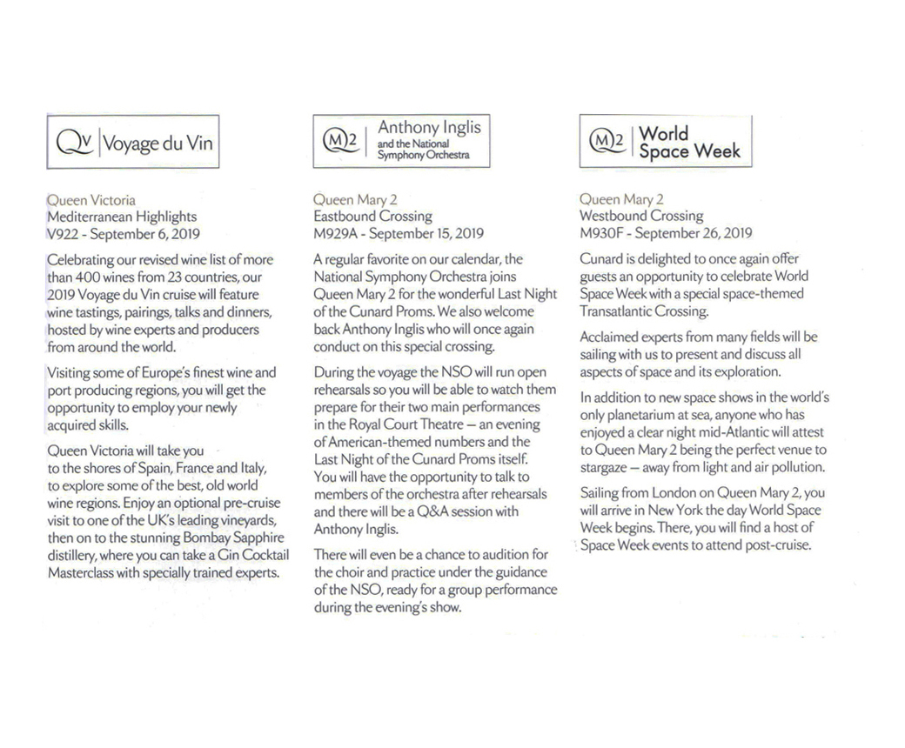
Wine, the National Symphony Orchestra, a Space Week, a Fashion Week and a Big Band with a chorus are five different cruises that you cannot find on another cruise line

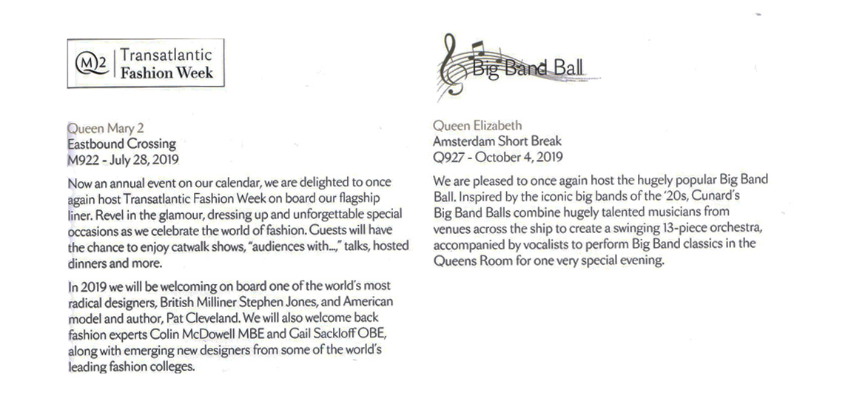
Cunard also offers cruises around the world. No other company offers it. Exclusivity is therefore a part of Cunard's specific market.

So, if you are looking for something different, you can have it only on a Cunard ship.

I will now close this presentation by two songs, one British and one American, that you have certainly heard at least one time in your life.

Rule Britannia!
Britannia rule the waves
Britons never, never, never shall be slaves.

Anchors Aweigh, my boys,
Anchors Aweigh.
Farewell to foreign shores,
We sail at break of day-ay-ay-ay.
Through our last night ashore,
Drink to the foam,
Until we meet once more.
Here's wishing you a happy voyage home.

